 | YEAR 9 COMMON  EPW 1 – SEMESTER 1 2018  Pascal’s Triangle and Mice Maze |  | 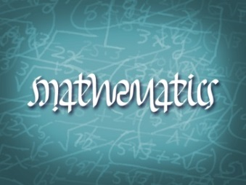
Name: ___________________________ |  | Teacher: _________________________
Date out: Week _____Date _________ |  | Date Due: Week _____Date ____________
EPW weighting: 10% of the year |  | Take Home Section: 5 marks.
This investigation consists of two parts.
- Part A is a take-home investigation.
- Part B is a 30 minute in-class validation test. You will be able to use Part A when completing Part B.

PART A – TAKE HOME SECTION

SECTION 1 PASCAL’S TRIANGLE

Below are the first six rows of Pascal’s triangle.

 |  |  |  |  |  |  | Sum of Rows
Row 1 | 1 |  |  |  |  |  | 1
Row 2 | 1 1 |  |  |  |  |  | 2
Row 3 | 1 2 1 |  |  |  |  |  | 4
Row 4 | 1 3 3 1
Row 5 | 1 4 6 4 1 |  |  |  |  |  | __
Row 6 | 1 5 10 10 5 1 |  |  |  |  |  | __
Row 7 | _ _ _ _ _ _ _ |  |  |  |  |  | __
Row 8 | _ _ _ _ _ _ _ _ |  |  |  |  |  | __
Row 9 | _ _ _ _ _ _ _ _ _ |  |  |  |  |  | __

- Complete the next three rows of the triangle.

- Complete the sum of each row. Describe the pattern that occurs with these numbers.

- Predict the sum of the numbers in the 15th row.

SECTION 2 MOUSE ESCAPE
A maze has been constructed as below, with a mouse placed in one corner, and the exit in another. The mouse has trained to navigate a maze such that it would always move down or to the right.
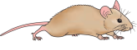
- How many different ways can the mouse reach the exit?

- How many different ways can the mouse reach the exit in the maze below?

If the maze was to be made much larger, we can see it would be much more difficult to correctly identify the number of ways (without accidently duplicating or missing out a possible route).

A systematic approach to obtain the number of possible routes in outlined below.

A 1 is written at this intersection, because there is only 1 way for the mouse to get here.


1
Similarly, there is only 1 way for the mouse to get here.
1
Since the mouse can only move down or right, there must also be only one way the mouse can reach these intersections, and hence we can fill them in with ones.
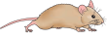
1
1
1
1
1
We must now look at the other intersections.

A 2 is written at this intersection, because there are 2 ways to get to this point. 1 from above, and 1 from the left.
2
1
1
1
1
1

3
A 3 is written at this intersection, because there are 3 ways to get to this point. 2 from above and 1 from the left.
2
1
1
1
1
1
Continuing this method by looking at one intersection at a time, we find there are 10 ways in total for the mouse to navigate through the maze.


4
10
6
3
3
2
1
1
1
1
1

- Using this newly learnt method, determine the number of routes through each of the following mazes.


- What do you notice about the numbers in the intersections?

Traps can be placed in the maze in order to trap the mouse. Fortunately, the mouse is clever enough to avoid them.
- Investigate how we might modify the process and the effect this will have on the possible routes through the maze.
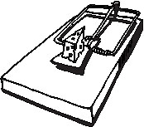



EXIT
EXIT

Answer = 4 Answer = 4





EXIT
EXIT

Answer = 5 Answer = 6





EXIT
EXIT

Answer = 7 Answer = 7

- Determine the total number of routes through each maze now that a trap has been placed in each of them.







